Distributed Computing

**Web Services for E-commerce using SOAP**

Jogebeth Gomez Salazar 15309001

2018

# System Design

**Use case diagram:**

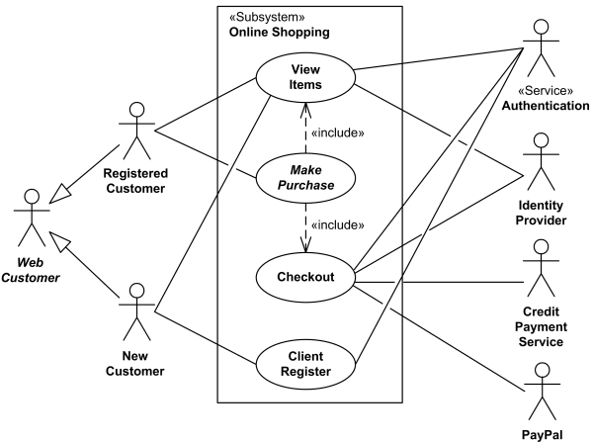

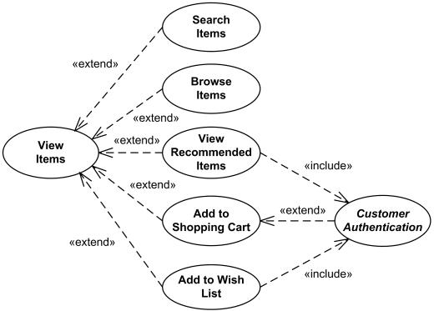

**Class diagram:**

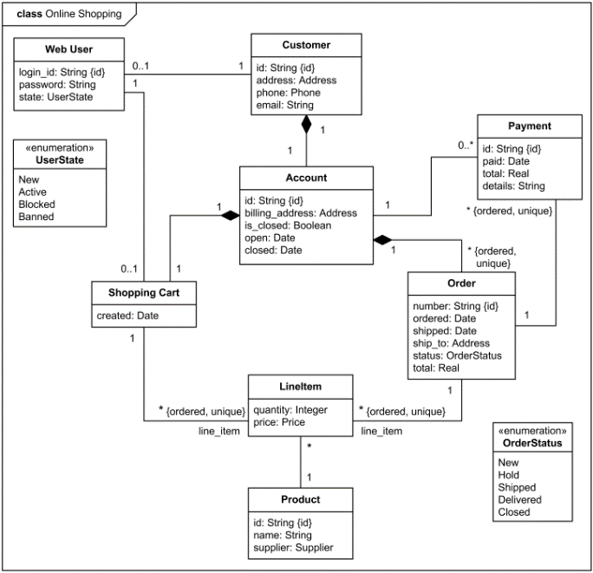

# Service Design

The service design is based on a Java server connected to a MySQL database, which uses SOAP, XML, WSDL and .jsp objects in order to access and manipulate the data online through a tomcat server.

The WSDL (shoppingOnline.wsdl) defines the specific operations of the service, the network protocol, and the endpoint address:

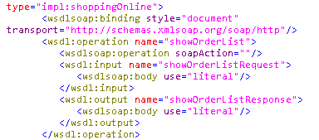

The referenced XMLSchema describes the structure and content of the SOAP message:

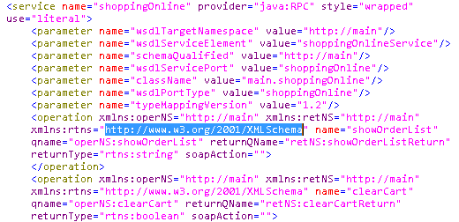

WS-Meta data Exchange defines three operations that respectively enable the querying of three kinds of metadata, making it easy for requesters to know the details of a WebService.

Finally the .jsp objects are used to configure the UI in HTML format.

The underlying Java-MySQL connection is accomplished by using a jdbc driver and configuring its options to access the local database:



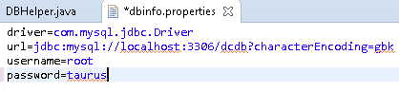

# Test Report

Accessing the dynamic HTML web page through the tomcat server and jsp ojects:

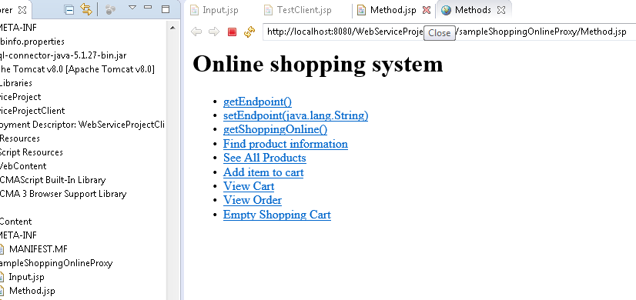

Successfully adding data to the db through the jsp objects, java and jdbc driver:

